Terrain, Textures and Environment Generation

In Class Exercises

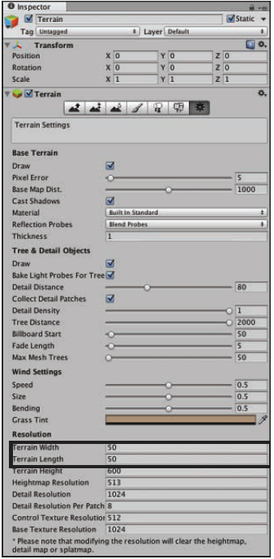Today you learn about terrain, how to create it, and how to sculpt it. You will also get hands-on experience with texture painting and fine-tuning. In addition, you learn to make large, expansive, and realistic-looking terrain pieces for your games.

DEF: TERRAIN**:**  The term terrain refers to any section of land that simulates a world’s external landscape.

* Tall mountains,
* Far plains
* Dark swamps … are all examples of possible game terrain.

Terrains are a flat meshes that can be sculpted into many different shapes. Like sand in a sandbox. You can dig into the sand or raise sections of it up.

* Terrains cannot overlap. (Cannot make things like caves or overhangs)
* Terrains have
  + Position
  + Rotation
  + Scale (although they aren’t usually changed).

1. Click the menu items GameObject > 3D Object > Terrain
2. The Terrain is too big. We need to modify some properties
3. Change the Terrain’s **Resolution** (length, width, and maximum height)
4. Select your terrain in the Hierarchy view.
5. 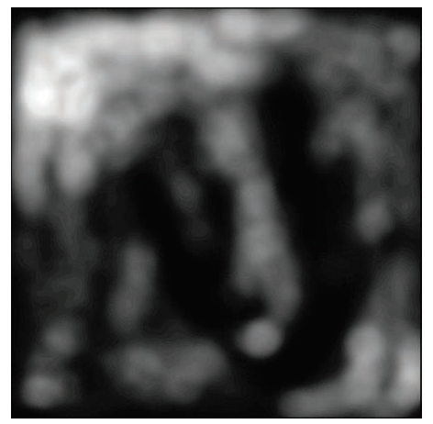In the Inspector view, locate and click the Terrain Settings button (the cog) (see side pic)
6. Locate the Resolution settings.
7. Currently, the terrain width and length are set to 500. Set these values both to 50.

DEF: TERRAIN SIZE**:**  Width and Height of your Terrain

HEIGHT MAP & SCULPTING

* 256 shades of gray are available in 8-bit images
* These shades range from 0 (black) to 255 (white).
* You can take a black-and-white image, (sometimes called a gray scale image)

and use it as something called a heightmap (a grayscale image that contains elevation information similar to a topographical map.

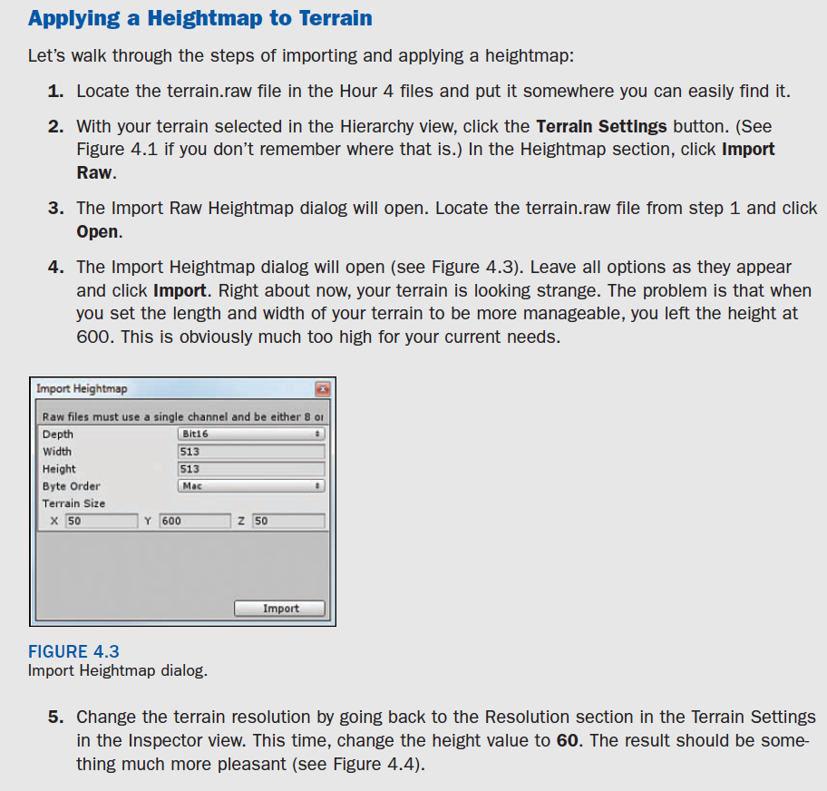

Calculating height

Your terrain should now look more like this:

The max height of the terrain defaults to 600 but is easily changeable.

(gray shade)/255 Å~ (max height)

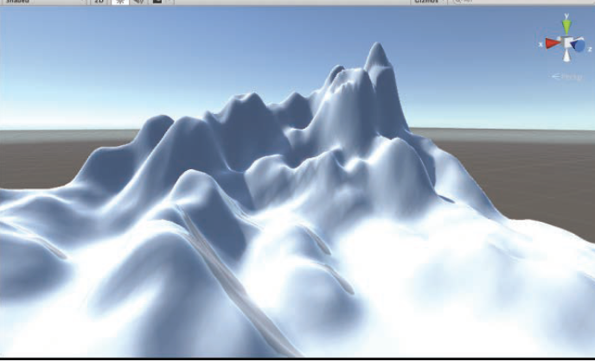

So far, the heightmap might seem random, but it is actually quite easy to figure out.

Everything is based on a **percentage of 255** and the **maximum height of the terrain**.

The max height of the terrain defaults to 600 but is easily changeable. If you apply the formula of (gray shade)/255 Å~ (max height) , you can easily calculate any point on the terrain. For instance, **black has a value of 0**, and so any spot that is black will be 0 units high ( 0/255 Å~ 600 ). **White has a value of 255** and therefore produces spots that are 600 units high ( 255/255 Å~ 600 ).

If you have a medium gray with a value of 125, any spots of that color will produce terrain that is about 294 units high ( 125/255 Å~ 600 ).

Unity Terrain Sculpting Tools

Unity gives you multiple tools for **hand sculpting** your terrain. You can see these tools in the

Inspector view under the component Terrain (Script). These tools all work under the same premise:

You use a **brush** with a given size and opacity to “paint” terrain. In effect, what you are doing is **painting a heightmap** that is translated into changes for the 3D terrain. The painting effects are cumulative, which means that the more you paint an area, the stronger the effect is on that area. Figure 4.5 shows these tools. Using these tools, you can generate pretty much any landscape you can imagine.

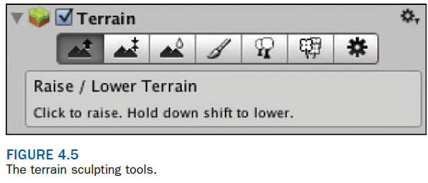

The first tool you will learn to use is the Raise/Lower tool. This tool, just as it sounds, enables you

to raise or lower the terrain wherever you paint. To sculpt with this tool, follow these steps:

1. Select a brush. Brushes determine the size and shape of the sculpting effect.

2. Choose a brush size and opacity. The opacity determines how strong the sculpting effect is.

3. Click and drag over the terrain in the Scene view to raise the terrain. Holding Shift when

you click and drag will instead lower the terrain. Figure 4.6 illustrates some good starting options for sculpting given the terrain size 50 Å~ 50 with a height of 60

Paint Tool

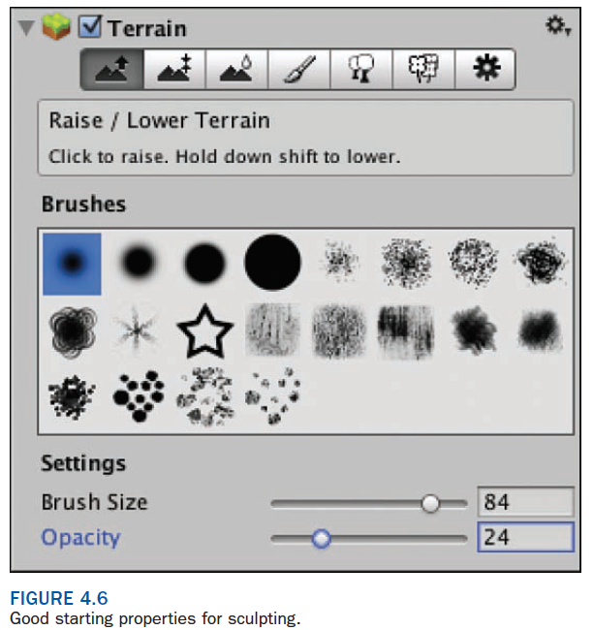The next tool is the Paint Height tool.

This tool works almost exactly as the Raise/Lower tool

except that it paints your terrain to a specified height. If the specified height is higher than the

current terrain, painting raises the terrain. If the specified height is lower than the current terrain,

however, the terrain is lowered. This proves useful for creating mesas or other flat structures

in your landscape. Go ahead and try it out!

Flattening Terrain

If, at any time, you want to reset your terrain back to being flat, you can do so by going to the **Paint Height tool** and clicking Flatten. One added benefit of this is that you can flatten the terrain to a height other than its default 0. If your maximum height is 60 and you flatten your heightmap to 30, you have the ability raise the terrain by 30 units, but you can also lower it by 30 units. This makes it easy to sculpt valleys into your otherwise flat terrain.

Smooth Height Tool

The final tool you will use is the Smooth Height tool. This tool doesn’t alter the terrain in highly noticeable ways. Instead, it removes a lot of the jagged lines that appear when sculpting terrain. Think of this tool as a polisher. You will really only use it to make minor tweaks after your major sculpting is done.

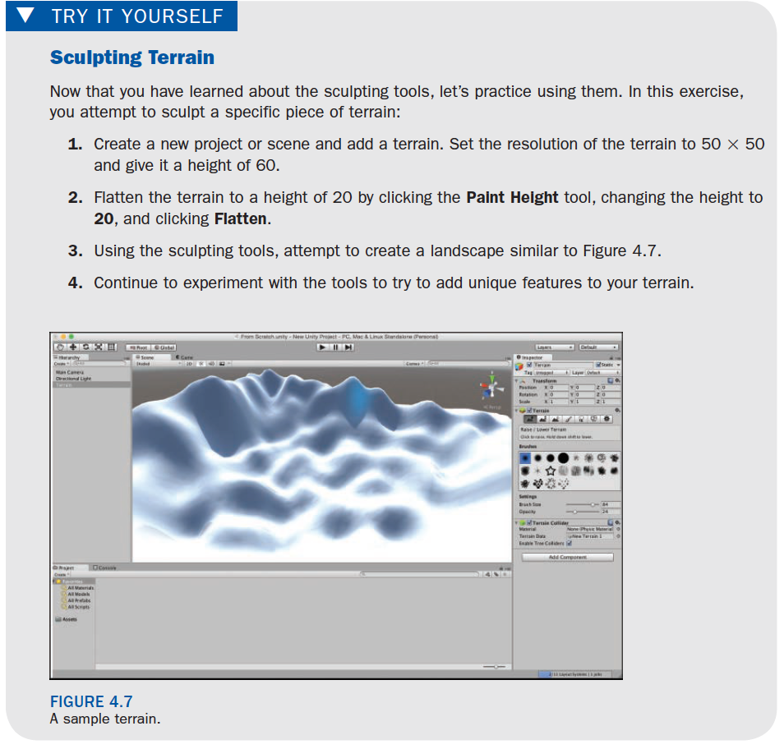

Practice, Practice, Practice

Developing strong, compelling levels is an art form in itself. Much thought has to be given to the placement of hills, valleys, mountains, and lakes. Not only do the elements need to be visually satisfying, but also they need to be placed in such a way as to make the level playable. This type of skill doesn’t develop overnight. Be sure to practice and refine your level-building skills to make exciting and memorable levels.

▼

Terrain Textures

You now know how to make the physical dimensions of a 3D world. Even though there may be a lot of features to your landscape, it is still bland and difficult to navigate. It is time to add some character to your level. In this section, you learn how to texture your terrain to give it an engaging look.

Importing Terrain Assets

Like sculpting terrain, texturing terrain works a lot like painting. You select a brush and a texture and paint it onto your world. Before you can begin painting the world with textures, however, you need some textures to work with. Unity has some terrain assets available to you, but you need to import them first. To load these assets, click Assets > Import Package > Environment. The Importing Package dialog will appear (see Figure 4.8 ). This dialog is where you specify exactly which assets you want to import. Deselecting unneeded items is a good idea if you want to keep your project size down. For now, just leave all options checked and click Import. You should now have a new folder under Assets in the Project view called Standard Assets. This folder contains all the terrain assets you will be using in the rest of this hour.

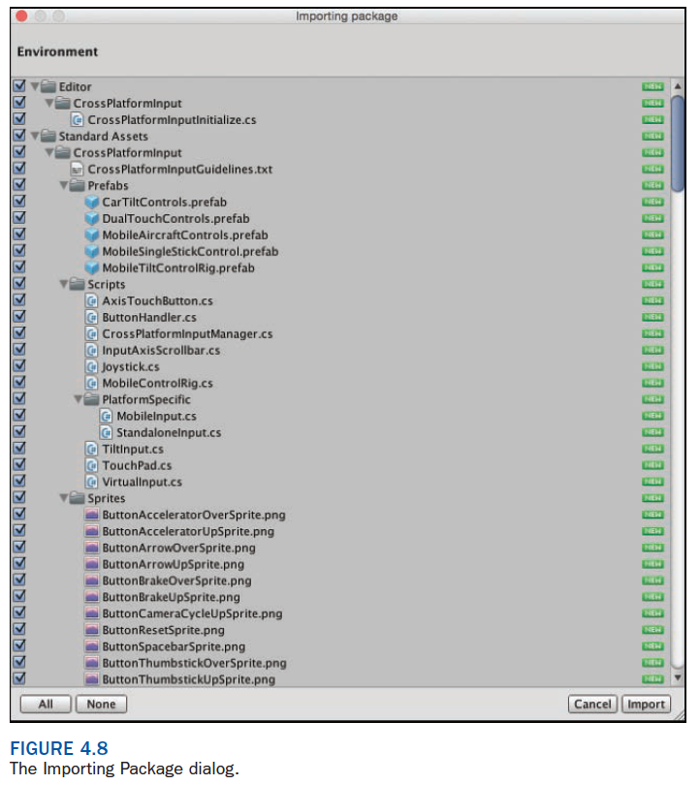

Texturing Terrain

The terrain texturing procedure is simple in Unity and works a lot like the sculpting. The first

thing you need to do is load a texture. Figure 4.9 illustrates the texturing tool in the Inspector,

which you access by selecting the Terrain in your Hierarchy. Pay attention to the three numeric properties: brush size, opacity, and target strength. You should be familiar with the first two properties, but the last one is new. The target strength is the maximum opacity that it achievable through constant painting. Its value is a percentage, with 1 being 100%. Use this as a control to prevent painting your textures on too strongly.

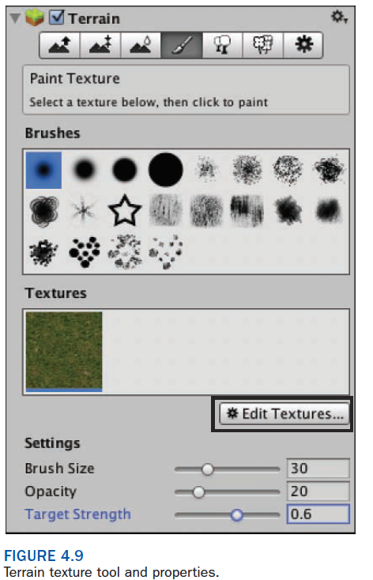

To load a texture, follow these steps:

1. Click Edit Textures > Add Texture in the Inspector (not the Unity menus).
2. 2The Add Terrain Texture dialog will appear. Click Select in the Texture box (see Figure 4.10 ) and select the GrassHillAlbedo texture.
3. Click Add (there is no need to add a “normal map”).



 